Week 3: Seller and Inventory Management System

Scenario:
The e-commerce company sells products supplied by multiple sellers. The system should maintain seller details, track products supplied by each seller, and monitor inventory levels to ensure product availability.

1.Create Seller and Inventory Tables

2. Establish Relationships

Seller and Product
One seller can supply multiple products.
One product can be supplied by one or multiple sellers.
Relationship:
Seller → Product is one to many

Product and Inventory
Each product has inventory information.
Inventory tracks available stock.
Relationship:
Product → Inventory is one to one

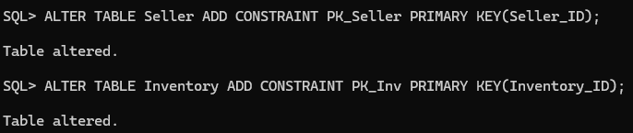
Primary Key Added for Both Tables

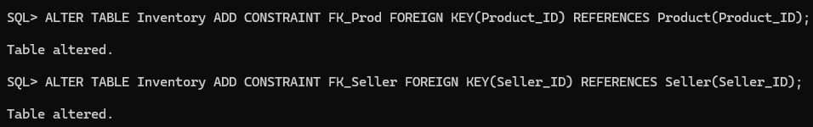
Foreign Key for Inventory Table

3. Constraints

Constraint to Make Unique Email ID

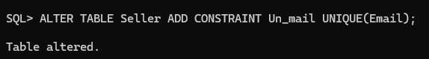

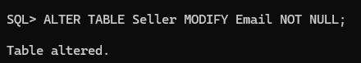
To Make Email NOT NULL

Add Constraint to Check the Stock Quantity is Positive
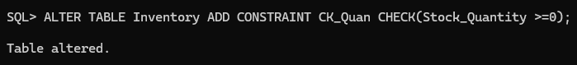

4. Insert Values to Seller Table

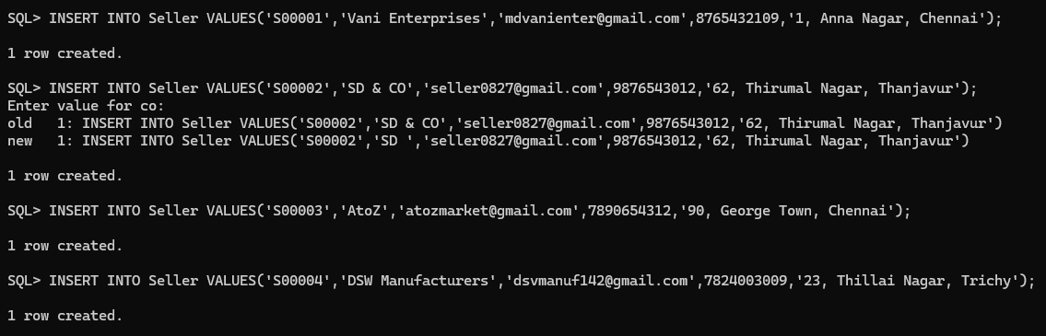

Display Seller Table
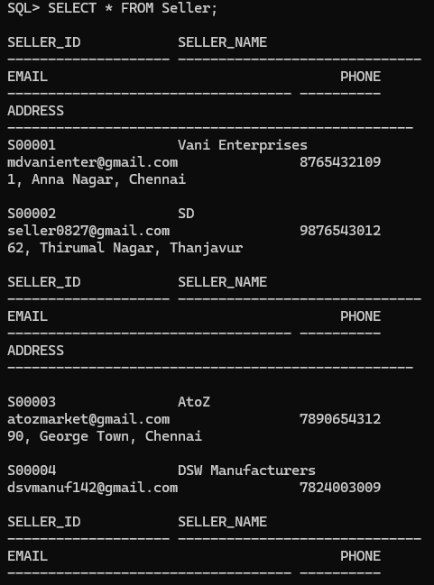

5. Insert Values to Inventory Table

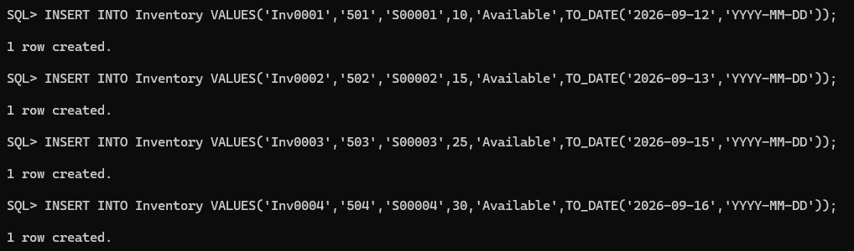

Display Inventory Table

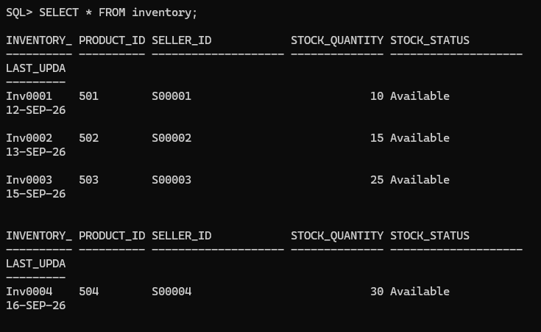

Report 1: Seller-wise Product Report

Display:
- Seller name
- Number of products supplied
- Available stock
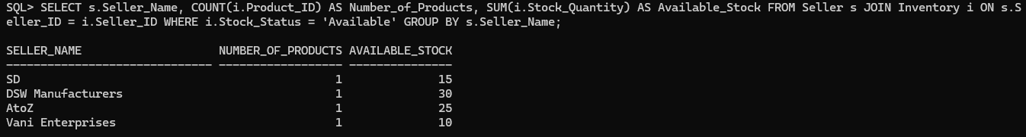

Report 2: Stock Availability Report

Display:
- Product name
- Stock quantity
- Stock status
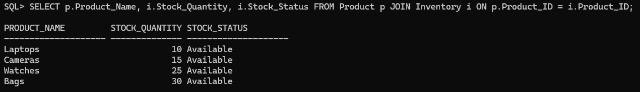

Report 3: Inventory Analysis

1. Total Products Available
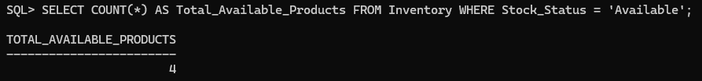

2. Products Out of Stock
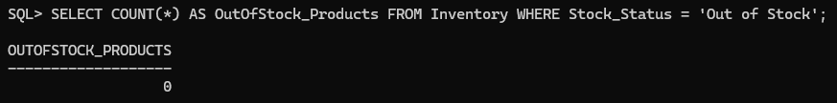

3. Highest Stocked Products

4. Average Inventory Quantity
